**KIRA EXPERIMENT (MANUAL PAIRING)**

**ANTIKA DAS – 09/09/2020**

**Default Kira Pairing:**

NIPGBoard kira algorithm works with a set of pre-defined similar/dissimilar image pairs and then run the training on those pairs and evaluate the clustering progress.

According to the default kira algorithm

15% of all TN and 15% of all FN dataset will randomly be connected as a graph for positive pairwise constraints and rest of the data will be connected by transitivity.

TN-TN🡪positive constraints

FN-FN🡪 positive Constraints

TN-FN🡪 Negative Constraints

**Observed output of default kira algorithm :**

According to my previous experiment “**NIPGBOARD KIRA EXPERIMENT REPORT.docx”** the clusters I got from Tsne, Pca and Umap with different epochs(10,35,50) with both balanced and unbalanced dataset were not very promising even though there were few good clusters but unfortunately with few mixed images.(Among all T-sne with higher number of epochs were giving quite a good result in terms of clustering but not proper separation of clusters).

**Hand-based Kira Pairing:**

As a part of next step of the experiment I used hand-based kira pairing of positive and negative image pairs using visual realization of clusters.

Techniques used:

* This time I took total 500 balanced dataset (250 FN/250 TN)—selected randomly.
* My strategy to improve the clusters by hand-based pairing was, first choosing those clusters which have maximum number of TN or FN with few scattered FN or TN in it respectively. After visually selecting those clusters my next step was adding those (all) scattered images(odd ones or which should not belong to the cluster) as positive pairs with each other (TN-TN / FN-FN) and their neighbors which is the opposite labelled images as negative pairs manually.
* I did not consider the regions where there were not good clusters or there were same amount of TN-FN mixed.

**Expected VS. Observed Results from Hand-based Kira pairing:**

Our goal or expectation from the hand based kira pairing wasbreaking /separating the clusters from the scattered images inside it and make better clusters. Even though the hand based pairing could not meet the expectation totally but still it showed some promising results with improved clusters(not totally separated) which could be beneficial for the further experiments. There are also few images which might cause the problem in order to not separating the clusters properly. The answer could be found if we could look in the feature description of such images and finding out their pattern which might confuse the network.

***\*\**** *The improvement of pattern (separation) of the clusters are highly dependable on how and what images we are selecting for the pairing manually. So we need some concrete ideas how and what images we should and should not add as positive and negative pairs while doing manual pairing.*

**Experiment Results:**

**\*\***upper image is from default kira pairing, below that one is hand based/manual pairing.

TSNE (EPOCH 35)-

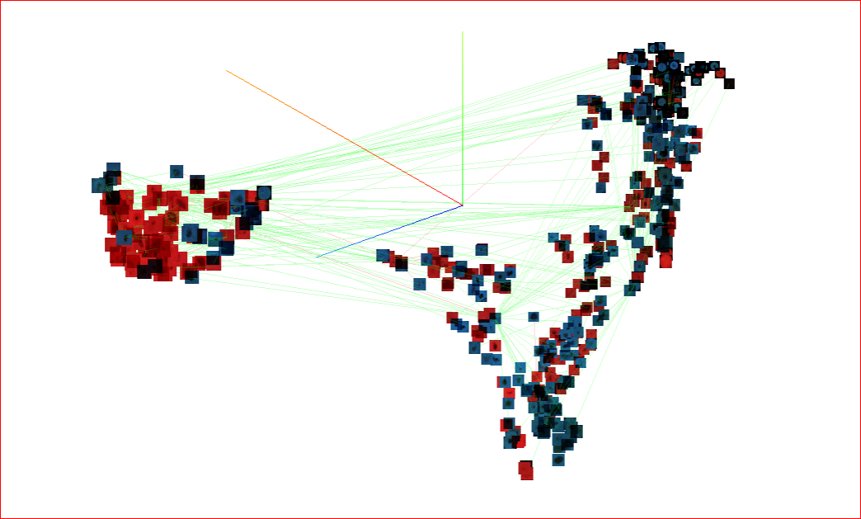

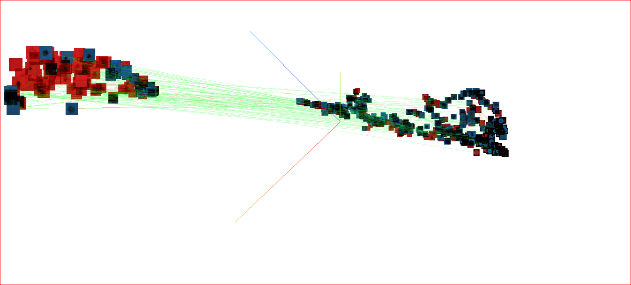

TSNE (EPOCH 50)-

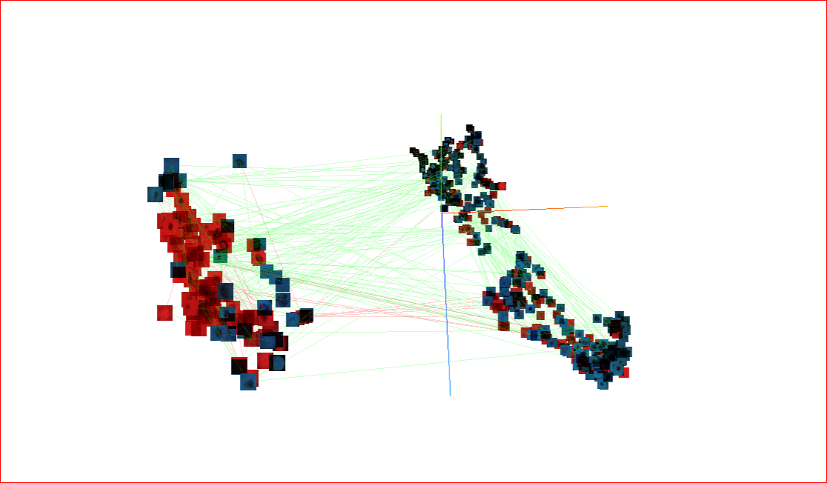

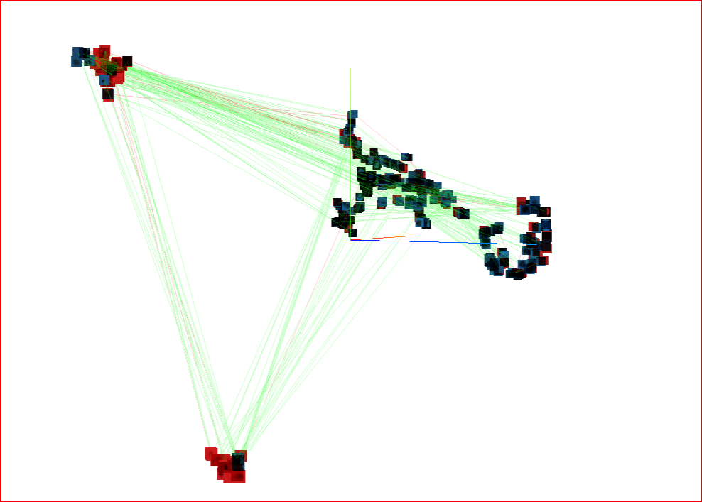

Umap (50 epochs):

